The person who takes medicine must recover twice, once from the disease and once from the medicine. William Osler, M.D
If all the medicine in the world were thrown into the sea, it would be bad for the fish and good for humanity. O.W. Holmes, Professor of Medicine Harvard University
Alternative medicine has become much more popular in the West in recent years. It seems that people are becoming increasingly worried about the side effects of drugs, and are turning to treatments such as homeopathy, osteopathy, yoga, reflexology and acupuncture to complement, or sometimes even replace, Western medicine.
An event in my life three or four years ago made me examine my own attitudes towards alternative medicine. After suffering from insomnia for a few months, I was feeling mentally and physically exhausted. A trip to my GP, and attempts at self-medication with nightly doses of Guinness and whisky, failed to bring any relief from my condition. My friend Tony, who was studying acupuncture at a college near London at the time, suggested that I visit an acupuncturist. Since I have a healthy fear of needles from waiting in line for vaccinations in gloomy school corridors, I was reluctant to take his advice, but by this time I was so tired that I was prepared to try almost anything.
I made an appointment with the only acupuncturist in my area, and after another nearly sleepless night, turned up at his room in the local alternative health centre the following morning. After taking my pulse, looking at my tongue, and asking a few questions about my diet and lifestyle, the acupuncturist correctly deduced that I was worn-out (I found this extremely impressive since he hadn’t asked me why I had come to see him.) He then inserted a needle in my right foot between my first and second toe, and, despite my anxiety, I fell asleep immediately. At the time I considered the whole experience to be close to a miracle.

What is acupuncture?
Acupuncture is based on the idea that energy flows through the human body along 12 lines or meridians. These meridians end up at organs in the body, and illness is the result of a blockage of the energy flow to these organs. To remove the blockage, an acupuncturist inserts very fine needles into the body at points along the meridians. This stimulates the flow of energy, and restores the patient’s health.

What can acupuncture be used to treat?
In the Far East acupuncture is used to treat a wide range of complaints, and is also used as a preventative medicine, since it is thought to increase the body’s resistance to infection. In the West, the treatment is often used to relieve headaches, dental pain, back pain, and arthritis, and to treat depression, asthma, stress, high blood pressure and anxiety.

Who uses acupuncture?
Since acupuncture is known to be effective against pain, it is not surprising that many sportspeople have experimented with acupuncture when fighting injury. Martina Hingis, the famous tennis player, had a wrist injury cured through treatment, and English Premier Division football club Bolton Wanderers employ an acupuncturist to keep their squad in good physical condition. While in Korea for the World Cup in 2002, soojichim, a Korean form of acupuncture, was very popular with the German football team.
Cherie Blair, a well-known human rights lawyer, and the wife of the British Prime Minister, was recently spotted wearing an acupuncture needle in her ear, suggesting that she uses the treatment to cope with stress. The Queen of England is also interested in acupuncture, although she doesn’t use the treatment herself – she and many of her family rely on another alternative medical treatment, homeopathy, to keep them healthy.

What are the risks?
Finally, if you do decide to visit an acupuncturist, it is important that you check that they are qualified and registered to practise acupuncture. In the past some people have experienced allergic reactions, broken needles and even punctured lungs while being treated, although this is very uncommon.

Glossary
allergic (adj.): caused by an allergy.
appendix (n.): a small tube-shaped part inside the body below the stomach.
arthritis (n.): an illness which causes the parts of the body where bones meet to become painful and often big.
asthma (n.): a medical condition which makes breathing difficult by causing the air passages to become narrow or blocked.
clinical (adj.): relating to medical treatment and tests.
deaden (adj.): to make something less painful or less strong.
dental (adj.): relating to teeth.
GP (n.): abbreviation for general practitioner: a doctor who sees people in the local area and treats illnesses that do not need a hospital visit.
homeopathy (n.): a way of treating illnesses using very small amounts of natural substances.
insomnia (n.): when you find it difficult to sleep.
miracle (n.): something that is very surprising or difficult to believe.
organ (n.): a part of an animal or plant that has a special purpose.
osteopathy (n.): the treatment of injuries to bones and muscles using pressure and movement.
preventive (also preventative) (adj.): preventive action is intended to stop something before it happens.
pulse (n.): the regular movement of blood through your body when your heart is beating.
puncture (v.): to make a hole in something.
reflexology (n.): a treatment in which your feet are rubbed and pressed in a special way in order to improve blood flow and help you relax.
sceptical (UK; US 'skeptical') (adj.): doubting that something is true or useful.
side effect (n.): another effect that a drug has on your body in addition to the main effect for which the doctor has given you the drug.
significant (adj.): important or noticeable.
vaccination (n.): a substance which contains a harmless form of a virus or bacterium (= extremely small organism), and which is given to a person or animal to prevent them from getting the disease which the virus or bacterium causes.
worn-out (adj.): extremely tired.

Do you disagree with any of the views in the text?

Would you expect similar or different results on the other alternative therapies you talked about before?

What do you think about the following things?
– Vitamin tablets for school kids
– Alternative exercises like yoga and tai chi in school PE lessons
– Doctors being able to supply placebo cures such as dummy pills to patients who they know have mainly psychological problems or in the place of anaesthesia
– Government funding for complementary therapies (= alternative medicine)
– Official licensing for alternative medicine practioners and banning of the quacks (= charlatans)
– Training for conventional doctors on how to become more warm, friendly, sympathetic and reassuring (using physical contact, aromas etc.)

If you were a doctor, how would you solve this dilemma?
– Placebos have some positive effects and usually no negative side effects but most people consider doctors prescribing things that they know are just placebos to be unethical

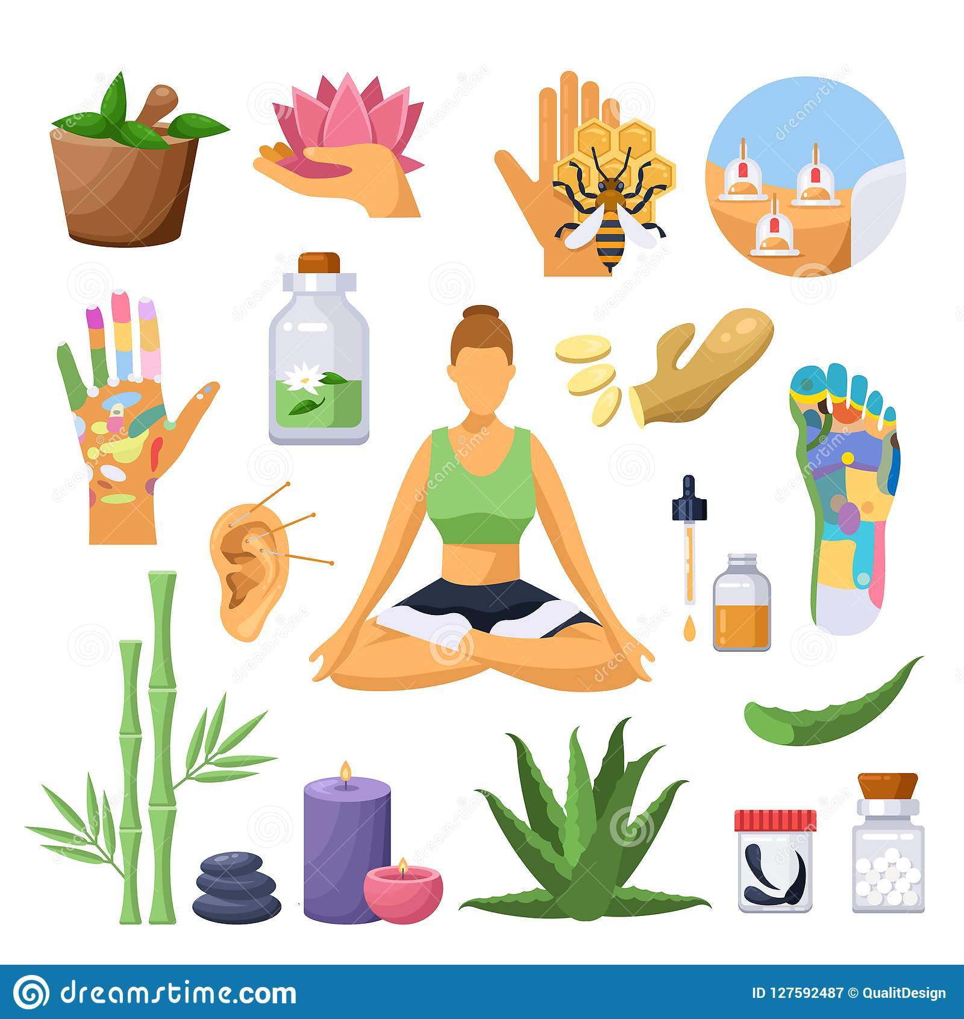
Choose one of the alternative therapies/ complementary therapies below that you know about. Explain what it is and what you think about it (e.g. what it is and isn’t useful for), then see if your partner agrees.
Acupuncture Aromatherapy Colonic irrigation
Colour therapy Folk remedies (e.g. cures for colds that run in your family)
Herbalism Homeopathy Juicing/ Detoxing
Laughter therapy Meditation Moxibustion
Reflexology Shiatsu Spiritual healing, e.g. reiki
Tai chi Traditional Chinese medicine Yoga

Scientific proof of alternative medicine
Today’s lesson is about an alternative kind of pain relief. Brainstorm possible cures for pain. What are the advantages and disadvantages of each one?
What would you do if you had the following things?
– Back pain/ Neck pain/ Shoulder pain
– Chronic headache
– Arthritis (pain in the joints – such as your hips, knees and knuckles – that is very common old people)
– Pain that your doctor can’t find a cure for

Choose one of the alternative therapies/ complementary therapies below that you know about. Explain what it is and what you think about it (e.g. what it is and isn’t useful for), then see if your partner agrees.
Acupuncture Aromatherapy Colonic irrigation
Colour therapy Folk remedies (e.g. cures for colds that run in your family)
Herbalism Homeopathy Juicing/ Detoxing
Laughter therapy Meditation Moxibustion
Reflexology Shiatsu Spiritual healing, e.g. reiki
Tai chi Traditional Chinese medicine Yoga

